Omnitrans Mobile Fare Validator FAQs
November 2023

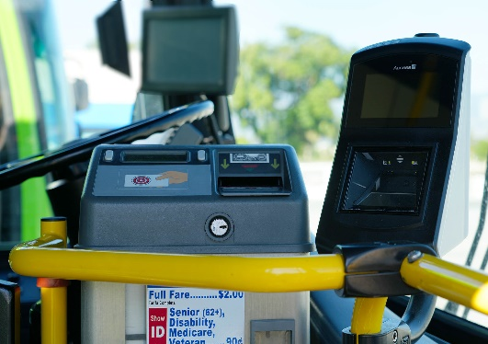
What are mobile fare validators?
Mobile fare validators (pictured in the photo at right next to the farebox) have been placed on all Omnitrans fixed route buses to record mobile fares purchased with the Transit or Token Transit app.
How do they work?
Just tap and go! When you board the bus, instead of showing your mobile fare phone screen to your driver as you do now, just tap your phone screen to the validator screen to record your fare. A green light and beep will indicate that your pass is accepted! A red light will indicate a problem with your ticket.
Why is Omnitrans using these validators?
Omnitrans received grant funding to purchase and install the validators to simplify the boarding process, limit close interaction time, and minimize the spread of germs with a contactless payment option.
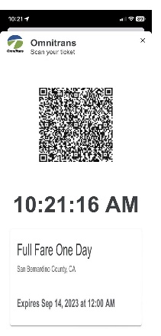
Will my mobile fare screen look different on my phones?
Yes. As you can see at left, mobile fare screens now will have a QR code to be “read” by the validator.
When should I start using the validators?
On Friday, December 1, 2023.
Can I still show my mobile pass to a driver if I don’t want to use the validator?
Please begin using the validators on December 1. After a brief grace period, no visual validation of mobile fares will be allowed onboard.
What else do I need to know?
Please remember to have your mobile pass ready when you board! Wi-fi is required to purchase a mobile pass, but not to activate it. Be ready to ride by activating your pass while at the bus stop to avoid delays.

