Omnitrans Mobile Fare Validator FAQs
November 2023

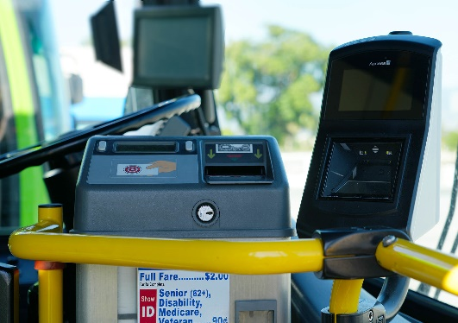
What are mobile fare validators?
Mobile fare validators (pictured in the photo at right next to the farebox) have been placed on all Omnitrans fixed route buses to record customer fares purchased via Token Transit or the Transit app.
How do they work?
When customers board, instead of showing their mobile fare phone screen to their coach operator as they do now, customers will hold their phone screen close to the validator screen to record their fare. A green light and beep will indicate that their pass is accepted, while a red light will indicate a problem with their ticket.
Why is Omnitrans using these validators?
Omnitrans received grant funding to purchase and install the validators, which are designed to limit close interaction time between coach operators and customers, simplify the boarding process and provide more accurate ridership data.
As technology progresses in the future, the validators also will be able to be used to record special program ridership such as Free Fares for School students.
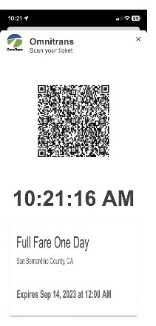
Will mobile fare screens look different on customers’ phones?
Yes. As you can see at left, mobile fare screens now will have a QR code to be “read” by the validator.
When will the validators ‘go live’?
On Friday, December 1, 2023.
Can customers still show their mobile pass to a coach operator if they don’t want to use the validator?
Customers are encouraged to begin using the validators on December 1. We will have a 2-week grace period to allow customers and operators to get used to the validator equipment. Beginning December 16, 2023, no visual validation of mobile fares will be allowed onboard.
Should operators stop recording mobile fares on the farebox when customers board?
From December 1 to January 2, 2024, operators should continue to record mobile fares on the farebox by pressing *5, even while validators are being used. This is to ensure/double-check that validators are recording data accurately.

What else do customers need to know?
It is important for customers to remember to have their mobile pass ready when they board the bus. As you know, wi-fi is required to purchase a mobile pass, but not to activate it. Customers should activate their pass while at the bus stop to be ready when the bus arrives and avoid delays.

