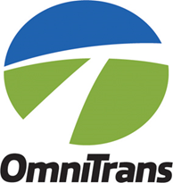

2024 Mobility Services

Call for (New and Expanded) Projects Timeline
Date | Action
January 5, 2024 | Call for (New) Projects applications available.
February 1, 2024, 10 am - 12 pm | Pre-application workshop at Omnitrans.
March 6, 2024, NLT 4:00 pm | Proposals due to Omnitrans.
April 11, 2024 | Funding recommendations presented to Omnitrans Administrative and Finance Committee
May 1, 2024 | Funding recommendations submitted to Omnitrans Board of Directors for approval.
May 2, 2024 | Notification of Projects Funded; begin Contract Execution process.
June 4, 2024 | Technical Workshop for Successful Applicants.
July 1, 2024 | Funded Projects scheduled to begin

